Abdominal Wall Reconstruction
Stem: 56-year-old obese (BMI 41 kg/m2) male who 3 y ago underwent an elective Sigmoidectomy.
He developed a postoperative wound infection and his wound healed by secondary intention. He developed incisional hernia and underwent elective open repair.
He initially did well but on 2-week postoperative visit, he developed wound infection and was explored in the operating room, the wound was opened, the fascia appeared intact, and cultures revealed MRSA. He was placed on a negative pressure wound therapy for approximately 6 months.
He now has a chronic draining sinus, he reports generalized malaise, denies fevers
PE: No erythema on exam
CT Abd reveals fluid around the mesh
Labs: Unremarkable.
Past medical history of hypertension and non–insulin-dependent diabetes

What is Your Differential Diagnosis?
- VAP (Ventilator associated pneumonia)
- Pneumonitis.
- Pulmonary contusion.
- PE.
- ETT migration.
- Mucus plug
What would you like to do now?
- Antipyretics.
- ABG.
- Labs: WBC 16000
- CXR: Previously seen infiltrate, dense, ETT 4 cm above the carina.
- Bronchoscopy and quantitative bacteriology. (Sputum Gram stains or cultures are considered inappropriate as they are neither sensitive nor specific. The specimen used for quantitative bacteriology should be obtained either through a bronchoscope or by the use of a coaxial catheter called the mini-BAL)
Describe how to perform Bronchoscopy?
- Introduced the bronchoscope through an endotracheal tube.
- Advance to the level of the vocal cords.
- Careful inspection of the entire airway is performed.
- Effort should be made to avoid unnecessary contact with the mucosa to avoid trauma.
- Collect specimens.
- Final assessment of the airway should be performed ensure adequate hemostasis.
- A post-procedural chest x-ray
Patient started requiring higher FiO2 and PEEP, suction aspirate are mucopurulent , what would you like to do?
- Start vancomycin and Cefepime for VAP. (high risk of MRSA in ICU patients) until the quantitative cultures results.

Incarcerated Femoral Hernia
Stem: 56 yo female presents to the emergency room with 18 hour history of nausea, vomiting, abdominal distension. Notes that she is otherwise healthy and was working in her garden yesterday and began to have pain in her right thigh radiating down the front of her leg. Thought it was a muscle strain so laid down for a couple hours but was awakened overnight by a feeling of nausea and abdominal pain and came to the emergency room.
PMH: HTN
PSH: None
Physical exam
- Afebrile
- Abdomen moderately distended, diffusely tender without rebound or guarding, no masses, + BS
- Rectal: Normal tone, no mass, GUAIC -
- Extremities: Firm tender mass with erythema at right superomedial thigh
Labs: WBC 11.4, Hgb 12.6, electrolytes K 3.3, otherwise normal
Imaging:
- CXR normal
- KUB: c/w dilated small bowel with multiple air fluid levels
What is your Differential Dx?:
- SBO due to
  - Hernia
  - Malignancy
  - IBD
  - Gallstone Ileus
  - Intussusception
  - Adhesions (less likely since no prior surgery)

What Would you like to do?
- Obtain CT
CT scan notable for findings c/w SBO with transition point posterior at right inguinal ligament with loops of bowel noted on superomedial right thigh

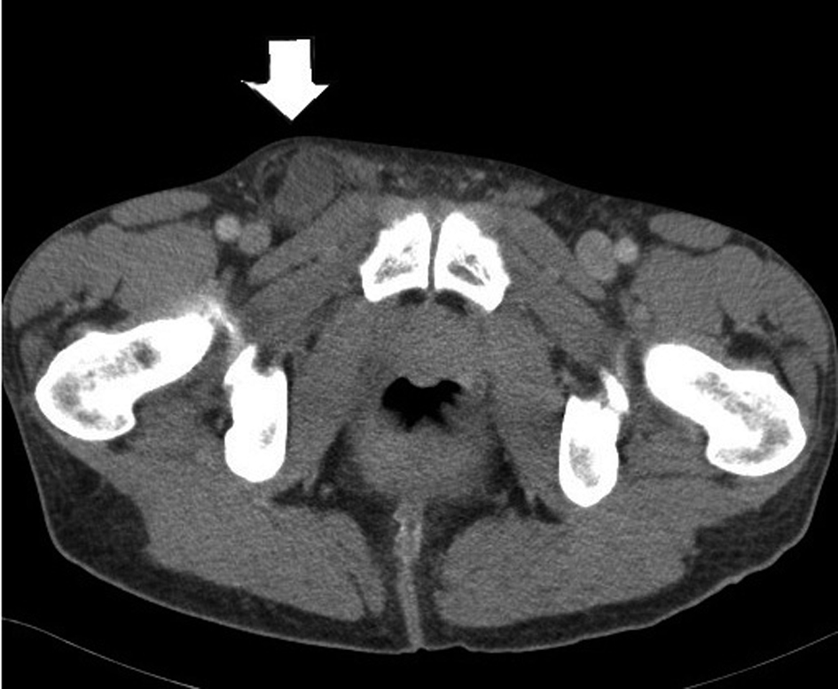

What is your diagnosis? Femoral hernia with Incarceration
What is your plan?
- Laparoscopic TAPP or TEPP
  - If attempt laparoscopically... ultimately unable to reduce
Open repair
  - Must describe opening inguinal floor / inguinal ligament to access femoral hernia / reduce

Open Lichenstein
- Oblique skin incision two fingerbreadths superior to inguinal ligament, carried through subcutaneous tissue
- External oblique fascia is identified and incised along direction of fibers
- Isolate cord structures from hernia sac
- Transect hernia sac (ensuring no sliding hernia) or reduce contents back intraabdominally
- Polypropylene mesh secured to pubic tubercle medially, inguinal ligament inferiorly, rectus sheath/internal oblique superiorly
- Reapproximate external oblique

  - Hernia repair plan if bowel ischemic? Tissue repair – McVay
    - A RLQ incision is made and the external oblique aponeurosis is opened through the external ring. Care should be taken to preserve the ilioinguinal nerve. Cooper's ligament is dissected free.
    - A relaxing incision should be made to reduce tension from this tissue repair. The relaxing incision should extend from the just above the pubis superiorly in the plane of fusion of the external oblique aponeurosis and the anterior rectus sheath.
    - The hernia sac is dissected free, excised and then closed.
    - Preperitoneal tissues are closed with a running absorbable suture.
    - Interrupted sutures are then placed between the transversus abdominis and Cooper's ligament, transitioning to the femoral sheath, superior laterally, allowing the spermatic cord to exit through the newly created internal ring.
    - The external oblique is closed.

Leak S/P Bariatric Surgery
Stem: A 45-year-old male presents to the emergency room with left chest and back pain, nausea, shortness of breath, and subjective fever. He underwent an uncomplicated laparoscopic bariatric procedure 10 days earlier in another hospital, and his current body mass index (BMI) is 58 m/kg2.
PE: Diaphoretic. Vitals: Temp 38.5°C, HR 114, Bl.Pr 114/75, RR 20, O2 94%. Abdomen is nontender and incision sites are dry and intact without signs of erythema or drainage.
PMH/PSH: GERD, HTN, Hyperlipidemia, COPD, appendectomy.
Social History: Prior smoker, drinks EtOH weekly.
Meds: Metformin.
Family history: Unremarkable.

Labs: CBC (WBC 18000, H&H 11/32) BMP (Na 144, k 4.5, Cl 98, Cr 2.9) Troponin Normal. Lactate 3.9.

What is your Differential Diagnosis?
- GI leak.
- Postoperative bleeding.
- Missed bowel injury.
- Missed pancreatic injury.
- PE.
- MI
What would you like to do now?
- Resuscitation: Two wide bore IV cannulas, IVF , Broad spectrum Abx.
- Obtain operative report.
- CT Abdomen and pelvis: What Contrast? Oral.
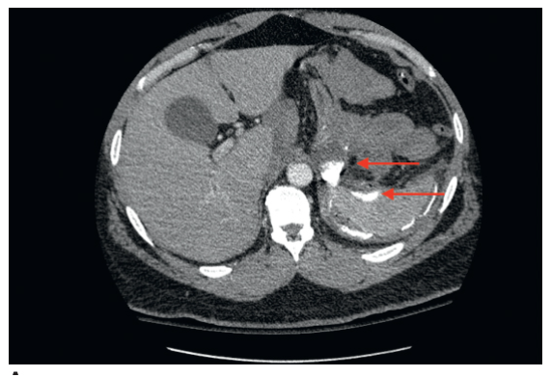

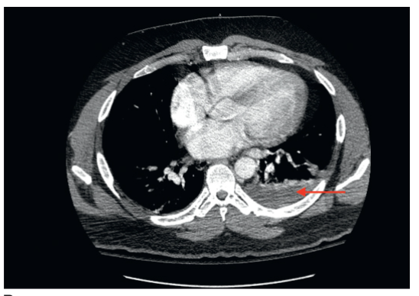
Contrast extravasation and extraluminal air along with a complex fluid collection located in the left subdiaphragmatic space.
You obtain and review the operative report, patient procedure was sleeve gastrectomy, what is your diagnosis in this case and how would you proceed.
- Gastric staple line leak, presenting with sepsis.
- Laparoscopic exploration. (Preferred) for irrigation and Drainage.
Describe how you would perform the procedure?
- Veress needle at Palmer’s point.
- Port is placed in the left upper quadrant. Angled laparoscope (5 or 10 mm)
- The patient is placed in the steep reverse Trendelenburg position, and additional ports are placed.
- Careful exploration of the left upper quadrant with blunt atraumatic graspers.
- Identify and drain any abscess cavity.
- Irrigate copiously with warm saline.
- Place one or more drains into the cavity spaces.
(Examiner please note, Identification of the exact location of the leak is not necessary as primary repair is often not feasible, and narrowing by overzealous attempts at repair of a sleeve or gastric bypass pouch leak can result in a stricture. )
- You identify the leak site, now what? Omental patch , placing seromuscular sutures through healthy gastric tissue and omentum.

- Consider placing feeding jejunostomy. Describe?
  - Place four sutures (2-0 braided absorbable sutures are used typically) in a diamond formation along the antimesenteric portion of the small bowel.
  - Enterotomy is created in the middle of the four sutures.
  - 12- to 14-Fr silastic feeding tube is advanced into the bowel directing it distally along the jejunum.
  - The four sutures are anchored to the abdominal wall
  - The drain is then sutured to the skin with a 3-0 nylon suture.
What are some protentional complications that can occur during or following this takeback surgery?
- Splenic injury
- Pancreatic injury.
- Splenic flexure colon injury.
- Gastrocolic fistulas
- Chronic fistula from leak site.
C

